Vincent Ryan & Paul Singleton

7/14/24

Module 10- Milestone 2

## Updated ERD

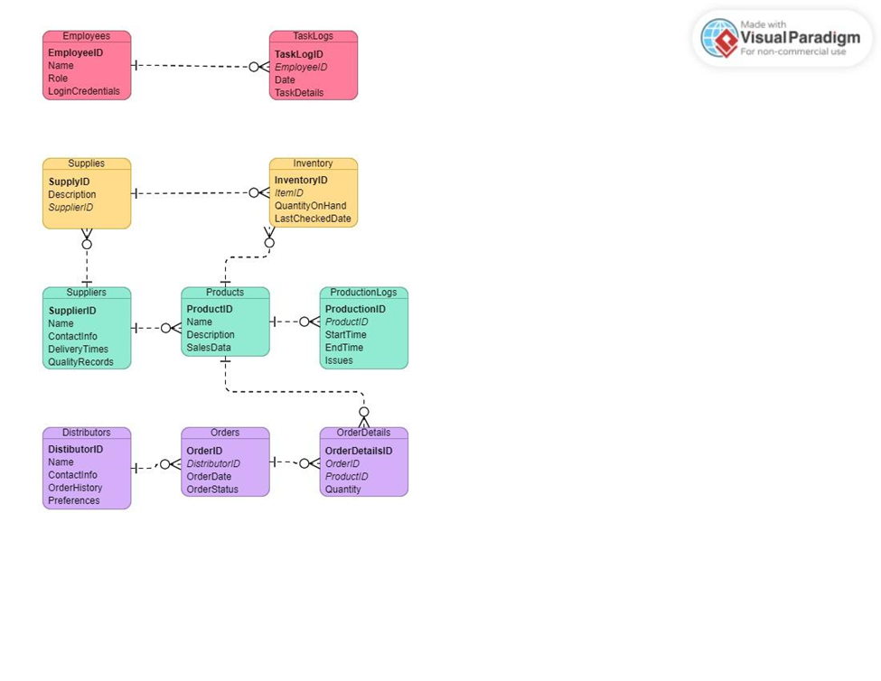

## Python Results

-- SELECTING all from employees --

employees_id: 1

employees_name: Janet Collins

employees_role: Finances

employees_id: 2

employees_name: Roz Murphy

employees_role: Marketing

employees_id: 3

employees_name: Bob Ulrich

employees_role: Marketing Assistant

employees_id: 4

employees_name: Henry Doyle

employees_role: Production Manager

employees_id: 5

employees_name: Maria Costanza

employees_role: Distribution

employees_id: 6

employees_name: Stan Bacchus

employees_role: Owner

employees_id: 7

employees_name: Davis Bacchus

employees_role: Owner

-- SELECTING all from task_logs --

task_logs_id: 1

task_logs_date: 2024-02-05

task_logs_details: Prepare quarterly report

employees_id: 1

task_logs_id: 2

task_logs_date: 2024-02-12

task_logs_details: Organize marketing event

employees_id: 2

-- SELECTING all from supplies --

supplies_id: 1

supplies_description: Bottles

suppliers_id: 1

supplies_id: 2

supplies_description: Corks

suppliers_id: 1

supplies_id: 3

supplies_description: Labels

suppliers_id: 2

supplies_id: 4

supplies_description: Boxes

suppliers_id: 2

supplies_id: 5

supplies_description: Vats

suppliers_id: 3

supplies_id: 6

supplies_description: Tubing

suppliers_id: 3

-- SELECTING all from inventory --

inventory_id: 1

inventory_qty: 600

supplies_id: 1

product_id: 1

inventory_verification: 2024-02-01

inventory_id: 2

inventory_qty: 400

supplies_id: 3

product_id: 2

inventory_verification: 2024-02-02

-- SELECTING all from suppliers --

suppliers_id: 1

suppliers_name: Bottle It Up

suppliers_contact_info: Nick Cork

suppliers_id: 2

suppliers_name: Pack It

suppliers_contact_info: Sarah Box

suppliers_id: 3

suppliers_name: Global Tubing

suppliers_contact_info: Carl Vats

-- SELECTING all from products --

products_id: 1

products_name: Merlot

products_description: Red Wine

products_id: 2

products_name: Cabernet

products_description: Red Wine

products_id: 3

products_name: Chablis

products_description: White Wine

products_id: 4

products_name: Chardonnay

products_description: White Wine

-- SELECTING all from product_logs --

product_logs_id: 1

products_id: 1

product_logs_start_time: 2024-02-15 09:00:00

product_logs_end_time: 2024-02-15 17:00:00

products_issues: None

product_logs_id: 2

products_id: 2

product_logs_start_time: 2024-02-20 09:00:00

product_logs_end_time: 2024-02-20 17:00:00

products_issues: Temperature fluctuation

-- SELECTING all from distributors --

distributors_id: 1

distributors_name: Vineyard Ventures

distributors_contact_info: Alex Green, alex.green@example.com

distributors_history: Long history of timely deliveries

distributors_preferences: Prefers red wines

distributors_id: 2

distributors_name: Wine Distributors Inc.

distributors_contact_info: Casey Blue, casey.blue@example.com

distributors_history: Excellent reputation

distributors_preferences: Prefers white wines

-- SELECTING all from orders --

orders_id: 1

distributors_id: 1

orders_date: 2024-03-10

orders_status: Shipped

orders_id: 2

distributors_id: 2

orders_date: 2024-03-20

orders_status: Pending

-- SELECTING all from order_details --

order_details_id: 1

orders_id: 1

products_id: 1

order_details_qty: 200

order_details_id: 2

orders_id: 2

products_id: 3

order_details_qty: 150